TABLE OF CONTENTS

Topic | Page
- Business Rules | 2
- Entity-Relationship Diagram (ERD) | 2
- Data Dictionary | 3
- Structured Query Language (SQL) Scripts | 5
- Advanced SQL Scripts | 15

1) Business rules
Business rules for the course booking system are listed below:
- A faculty may have many lecturers.
- Each faculty may have many students.
- A lecturer is allowed to teach up to 3 courses.
- Each course can only be taught by only 1 lecturer.
- A student can enroll up to 2 courses per enrollment.
- A student cannot enroll any of the passed course.

2) Entity-Relationship Diagram (ER-D)

Diagram 1 below is an ERD for the course booking system.

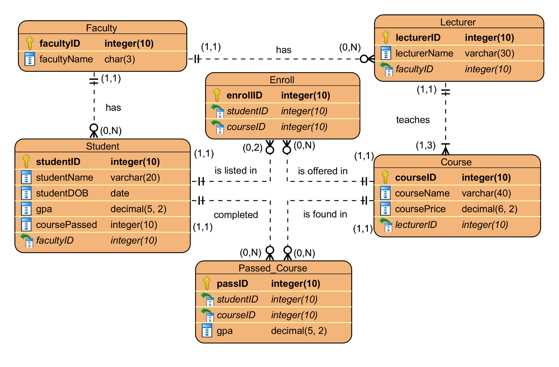

Diagram 1

3) Data Dictionary

3.1) Enroll

Field name | Data type | Field size | Constraint
enrollID | Integer | 10 | Primary key
studentID | Integer | 10 | Foreign key
courseID | Integer | 10 | Foreign key

3.2) Course

Field name | Data type | Field size | Constraint
courseID | Integer | 10 | Primary key
courseName | Varchar | 40 | Not null
coursePrice | Decimal | (6,2) | Not null
lecturerID | Integer | 10 | Foreign key

3.3) Faculty

Field name | Data type | Field size | Constraint
facultyID | Integer | 10 | Primary key
facultyName | Character | 3 | Not null

3.4) Student

Field name | Data type | Field size | Constraint
studentID | Integer | 10 | Primary key
studentName | Varchar | 20 | Not null
studentDOB | Date | - | Not null
Gpa | Decimal | (5,2) | Not null
coursePassed | Integer | 10 | Not null
facultyID | Integer | 10 | Foreign key

3.5) Lecturer

Field name | Data type | Field size | Constraint
lecturerlID | Integer | 10 | Primary key
lecturerName | Varchar | 30 | Not null
facultyID | Integer | 10 | Foreign key

3.6) Passed_Course

Field name | Data type | Field size | Constraint
passID | Integer | 10 | Primary key
studentID | Integer | 10 | Foreign key
courseID | Integer | 10 | Foreign key
Gpa | Decimal | (5,2) | Not null

4) Structured Query Language (SQL) scripts

The following SQL was used to create the Faculty table and to insert records into the table, which consists of the attributes facultyID and facultyName, where facultyID is an integer which is not null and is the primary key of the table, and facultyName is character data type with a maximum of 3 characters.

create table faculty
(facultyID int not null primary key,
facultyName char(3));

insert into faculty values (1,'FOE');
insert into faculty values (2,'FCI');
insert into faculty values (3,'FCM');
insert into faculty values (4,'FOM');

After that, the following command was executed to observe whether the previous commands were successfully executed:

select * from faculty;

Image 1 below shows the success of execution of all SQL codes above.

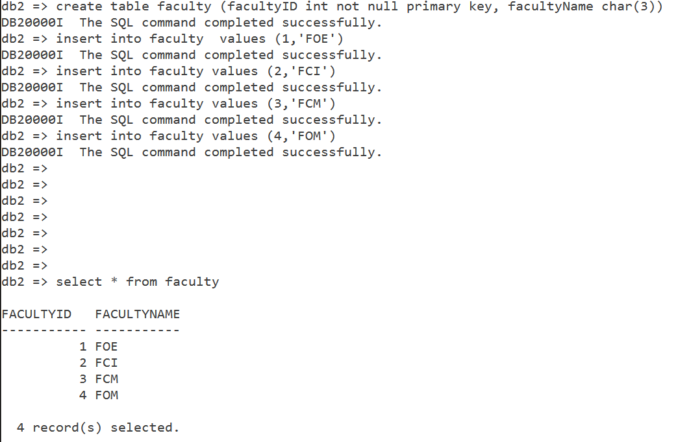

Image 1

The following SQL was used to create the Lecturer table and to insert records into the table, which consists of the attributes lecturerID, facultyID and lecturerName, where lecturerID is an integer which is not null, automatically increment by 1 for every new record inserted, also the primary key of the table, lecturerName is variable character data type with a maximum of 30 characters which represents the lecturer’s name, and facultyID representing which faculty the lecturer belong to, is a foreign key referencing to the Faculty table.

create table lecturer
(lecturerID int not null generated always as identity (start with 1 increment by 1) primary key,
lecturerName varchar(30), facultyID int,
foreign key (facultyID) references faculty(facultyID));

insert into lecturer (lecturername, facultyid) values ('Ian',1);
insert into lecturer (lecturername, facultyid) values ('Tan',1);
insert into lecturer (lecturername, facultyid) values ('Ah Lam',1);
.
. // for brevity
.
insert into lecturer (lecturername, facultyid) values ('Michael',4);
insert into lecturer (lecturername, facultyid) values ('Shukri',4);
insert into lecturer (lecturername, facultyid) values ('Divagar',4)

Image 2 below shows the success of execution of all SQL codes above.

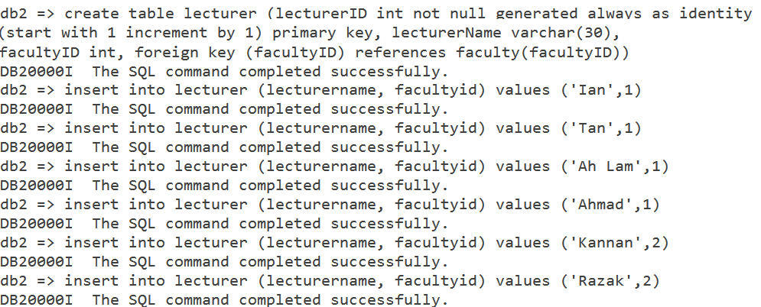

Image 2

After that, the following command was executed to observe whether the previous commands were successfully executed:

select * from lecturer;

Image 3 below shows the output after executing the above SQL script.

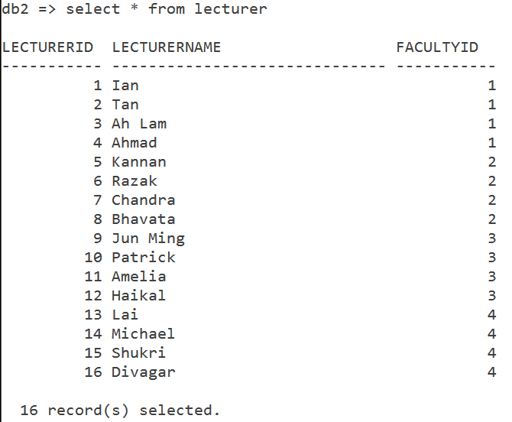

Image 3

The following SQL was used to create the Student table and to insert records into the table, which consists of the attributes studentID, studentName, studentDOB, gpa, coursepassed and facultyID. StudentID is an integer which cannot be null, also the primary key of the table and automatically increment by 1 for each new records get inserted into the table, studentName represents the student’s name is a variable character data type with a maximum of 20 characters. StudentDOB is a date data type represents the student’s birthdate. Gpa is a decimal with 5 length and 2 decimal places with a default value of 0.00 which stands for the student’s total grade point average. CoursePassed is an integer data type with a default value of 0 which represents the total amount of courses passed by a student FacultyID which represents which faculty that the student belongs to, is a foreign key referencing the Faculty table.

create table student
(studentID int not null generated always as identity (start with 1 increment by 1) primary key,
studentName varchar(20),
studentDOB date,
gpa decimal(5,2) with default 0.00,
coursepassed int with default 0,
facultyID int,foreign key (facultyID) references faculty(facultyID));

insert into student (studentname, studentdob, facultyid) values ('Hakim','1996-08-08',1);
insert into student (studentname, studentdob, facultyid) values ('Luqman','1996-03-21',1);
.
. // for brevity
.
insert into student (studentname, studentdob, facultyid) values ('Chloe','1996-06-04',4);
insert into student (studentname, studentdob, facultyid) values ('Brendan','1998-06-08',4);

Image 4 shows the success of execution of all SQL codes above.

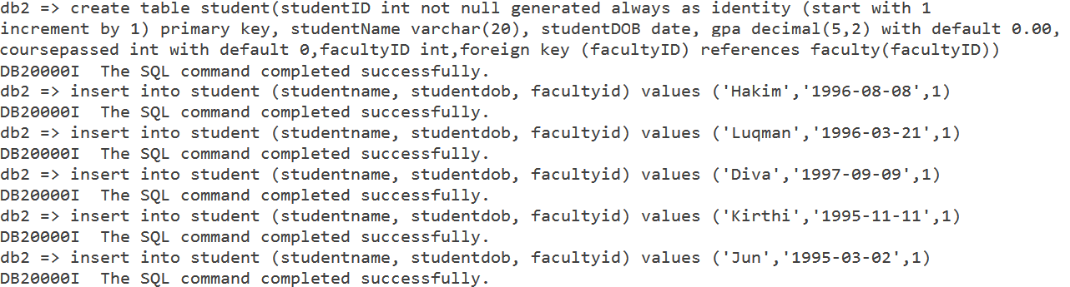

Image 4

After that, the following command was executed to observe whether the previous commands were successfully executed:

select * from student;

Image 5 below shows the output after executing the above SQL codes.

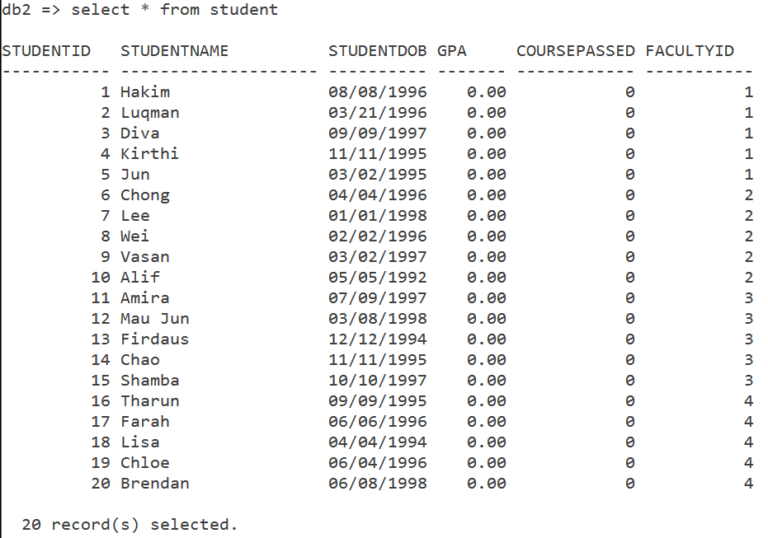
Image 5

The following SQL script was used to create the Course table and to insert records into the table, which consists of the attributes courseID, courseName, coursePrice and lecturerID. CourseID is an integer which is not null, also the primary key of the table and automatically increment by 1 each time a new record was inserted. CourseName which represents the course’s name, is a variable character data type with a maximum of 40 characters. CoursePrice which represents the price of the course, is a decimal with a length of 6 and 2 decimal places. LecturerID, representing which lecturer will be teaching the course, is an integer also a foreign key referencing the Lecturer table.

create table course
(courseid int not null generated always as identity (start with 1 increment by 1) primary key,
coursename varchar(40),
courseprice decimal(6,2),
lecturerid int,
foreign key (lecturerid) references lecturer(lecturerid));

insert into course (coursename, courseprice, lecturerid) values ('Calculus',699.99,1);
insert into course (coursename, courseprice, lecturerid) values ('Physics',699.99,2);
insert into course (coursename, courseprice, lecturerid) values ('Engineering Maths',549.99,3);
.
. // for brevity
.
insert into course (coursename, courseprice, lecturerid) values ('Soft Skill Development',250.00,12);
insert into course (coursename, courseprice, lecturerid) values ('Speaking and Writing in English',349.49,16);

Image 6 below shows the success of execution of all SQL codes above.

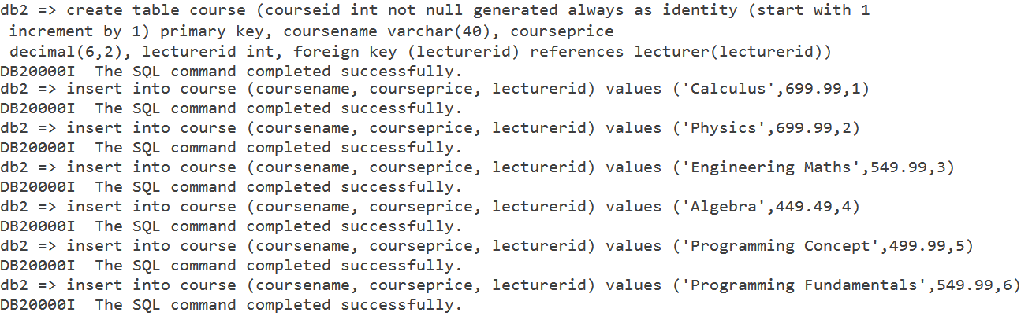

Image 6

After that, the following command was executed to observe whether the previous commands were successfully executed:

select * from course

Image 7 below shows the output after executing the above SQL codes.

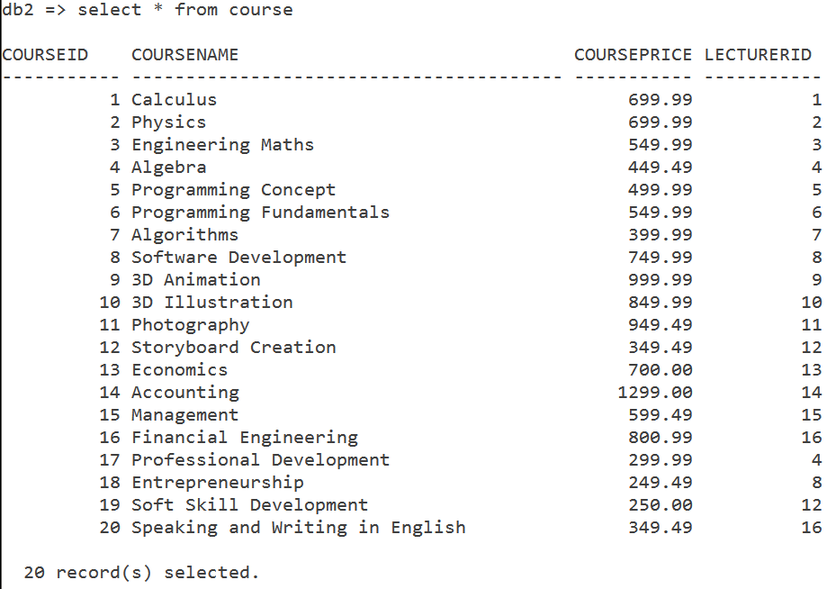

Image 7

The following SQL script was used to create the table Enroll and to insert records into the table, which consists of the attributes EnrollID, StudentID and CourseID. EnrollID is an integer which is not null, also the primary key of the table and automatically incremented by 1 for each new record inserted. StudentID, is a foreign key referencing to the Student table. CourseID is a foreign key referencing to the Course table.

create table enroll
(enrollid int not null generated always as identity (start with 1 increment by 1) primary key,
studentid int,
courseid int,
foreign key (studentid) references student(studentid),
foreign key (courseid) references course(courseid));

insert into enroll (studentid, courseid) values (1,1);
insert into enroll (studentid, courseid) values (1,3);
insert into enroll (studentid, courseid) values (2,2);
.
. // for brevity
.
insert into enroll (studentid, courseid) values (20,13);
insert into enroll (studentid, courseid) values (20,20);

Image 8 below shows the success of execution of all SQL codes above

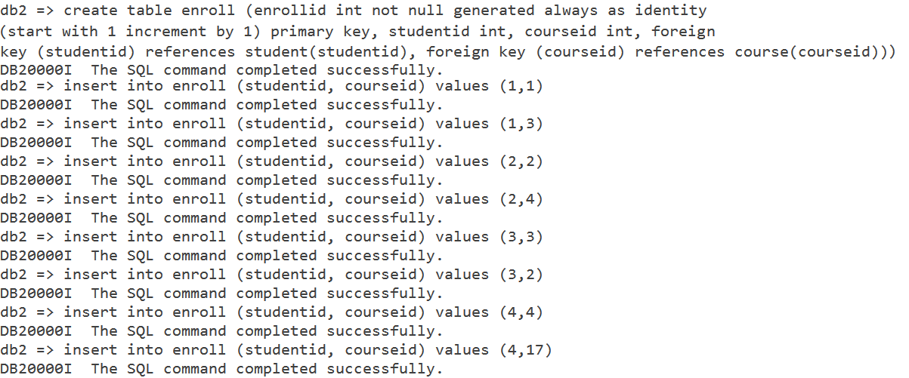

Image 8

After that, the following command was executed to observe whether the previous commands were successfully executed:

select * from enroll

Image 9 below shows the output after executing the above SQL codes.

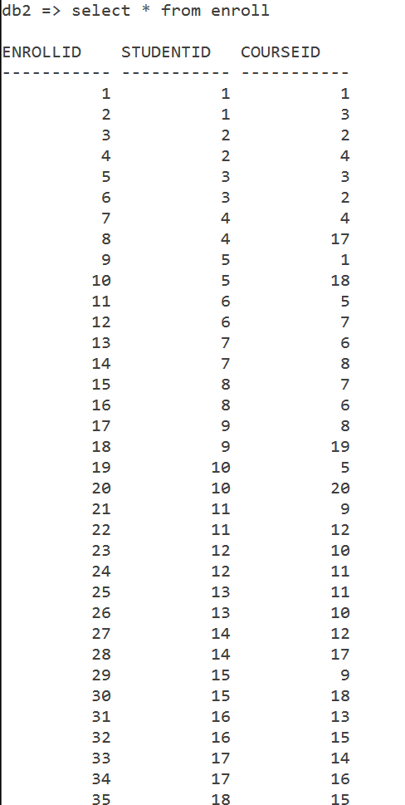

Image 9

The following SQL script was used to create the table Passed_course which consists of the attributes passID, studentID, courseID and gpa. PassID is an integer which is not null, also the primary key of the table and automatically increment by 1 for each new record inserted. StudentID is foreign key referencing to the Student table. CourseID is a foreign key referencing to the Course table. Gpa represents the grade point average achieved by the student on the course, is a decimal with a length of 5 and 2 decimal places.

create table passed_course
(passid int not null generated always as identity (start with 1 increment by 1) primary key,
studentid int,
courseid int,
gpa decimal(5,2),
foreign key (studentid) references student(studentid),
foreign key (courseid) references course(courseid));

Image 10 below shows the output after execution of the above SQL code.

Image 10

5) Advanced SQL scripts

5.1) Trigger

Firstly, the SQL script below was used to create the UPDATESTUDENT trigger, in order to keep track of students CGPA, by increment the number of course that have been completed by students and increment the student’s GPA.

create trigger updatestudent
after insert on passed_course
referencing new as n
for each row mode db2sql
update student
set gpa = gpa + n.gpa, coursepassed = coursepassed + 1
where n.studentid = student.studentid;
Image 11 below shows the output after execution of the above SQL code.

Image 11

The following SQL script is executed to insert values into table passed_course, to observe changes made by the trigger.

insert into passed_course (studentid, courseid, gpa) values (1,2,3.50);
insert into passed_course (studentid, courseid, gpa) values (3,4,2.60);
insert into passed_course (studentid, courseid, gpa) values (4,3,3.80);
.
. // for brevity
.
insert into passed_course (studentid, courseid, gpa) values (17,18,3.20);
insert into passed_course (studentid, courseid, gpa) values (20,14,2.90);

Image 12 below shows the output after executing the SQL codes above.

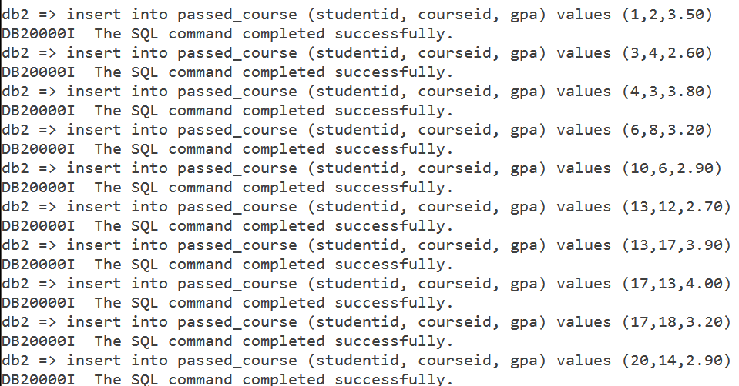

Image 12

After that, the following command was executed to observe whether the previous commands were successfully executed:

select * from passed_course;

Image 13 below shows the output after execution of the SQL code above.

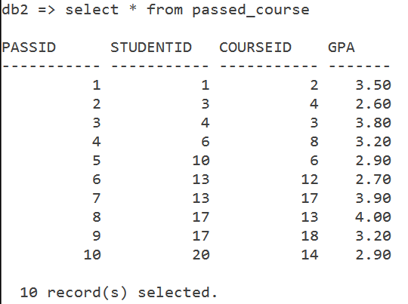

Image 13

To show that the trigger UPDATESTUDENT has been successfully implemented, the following SQL code was executed and the output is shown in Image 14.

select * from student;

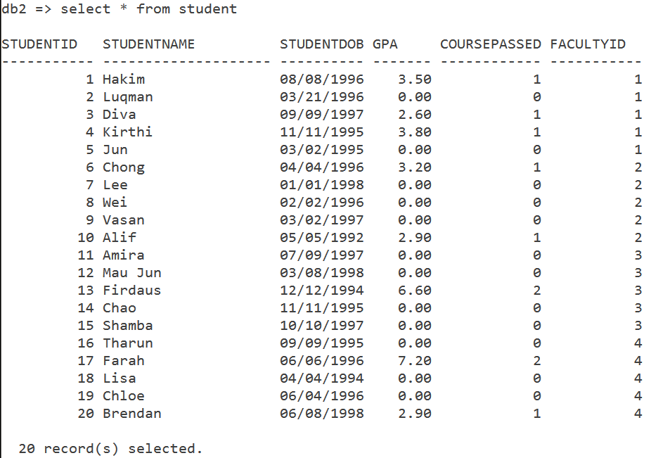

Image 14

5.2) Aggregate Function

The following SQL syntax was used to find the total course fee of a student where the studentID equals to 1.

select sum(courseprice) as totalfee
from course
where courseid in
(select courseid from enroll where studentid = 1);

Image 15 below shows the output after execution of the above SQL syntax.

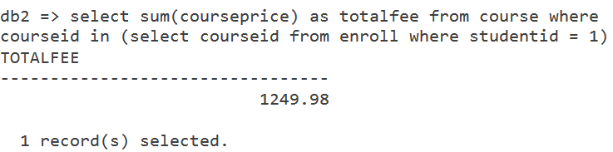

Image 15

5.3) Query with Group by and Having clause

The following SQL syntax was used to find the total amount of students grouped by faculties.

select facultyname, count(studentid) as totalstudents
from student, faculty
where student.facultyid = faculty.facultyid
group by facultyname having count(studentid) > 0;

Image 16 below shows the output after execution of the above SQL syntax.

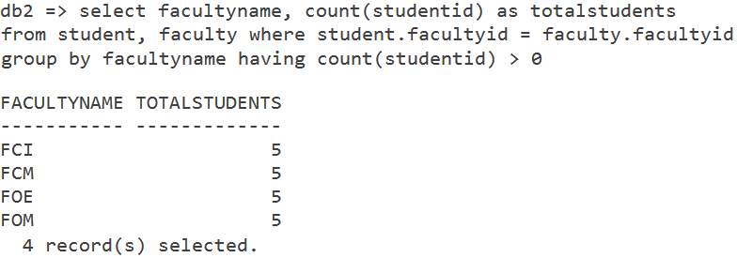

Image 16

5.4) Stored Procedure

The following stored procedure was used to

create procedure cgpa()
begin
declare gpapercourse varchar(150);
declare c cursor with return for s;
set gpapercourse = 'select studentid, gpa/coursepassed as cgpa
from student
where studentid in (select studentid from student where coursepassed >0 and gpa >0)';
prepare s from gpapercourse;
open c;
end

Finally the following SQL command was used to retrieve records based on the function of the stored procedure. The output of creating this stored procedure, as well as calling it is shown in the Image 17.

call cgpa();

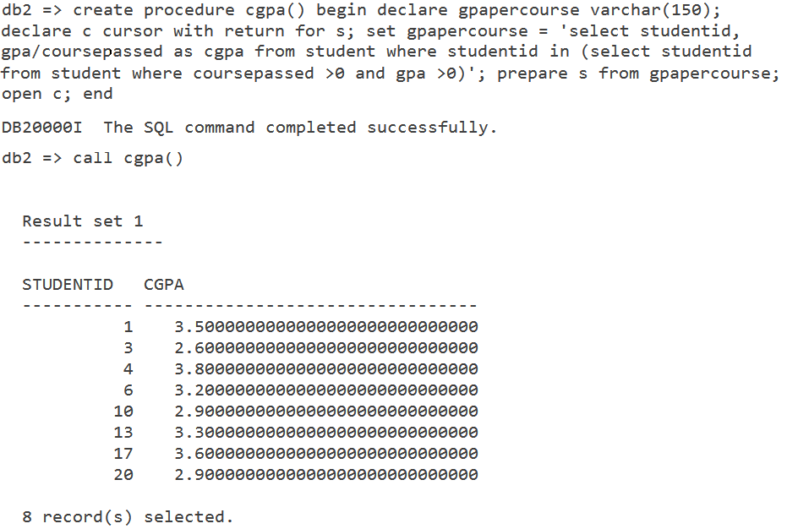

Image 17

5.5) View

The following SQL syntax is a View, created to show students who have passed any of their courses which means the student is not a new student. The output is shown in Image 18 below.

create view activestudent as
select studentid, studentname,gpa/coursepassed as cgpa, facultyname from student, faculty
where coursepassed <> 0 and
student.facultyid = faculty.facultyid;

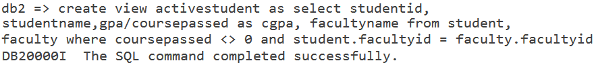
Image 18

Finally, the view is called upon by the execution of the following SQL syntax and the output is displayed as in Image 19 below.

select * from activestudent;

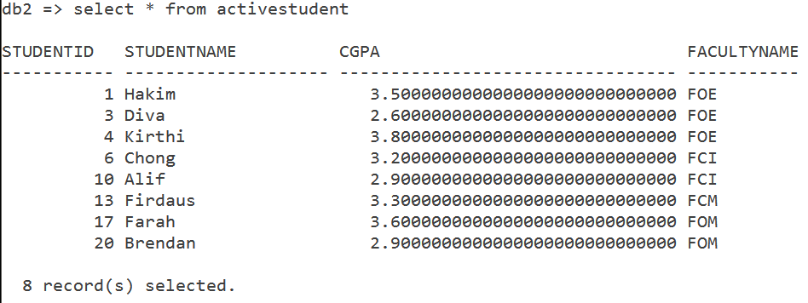

Image 19

5.6) Subquery/Nested Queries

The following subquery is executed to show records of the top 5 students with the highest CGPA. The output after executing this command is shown in Image 20.

select studentid, studentname
from student
where studentid in (select studentid from passed_course)
order by gpa/coursepassed desc limit 5;

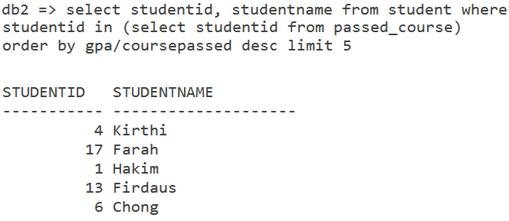

Image 20

